**Plant Disease Detection System for Sustainable Agriculture**

**Problem Statement:**  
Agricultural productivity is crucial for ensuring food security and economic growth. However, plant diseases significantly impact crop yields, leading to financial losses for farmers and threatening global food supply. Traditional methods of disease detection involve manual inspection, which is time-consuming, error-prone, and often requires expert knowledge. There is a need for an efficient, automated system to detect plant diseases at an early stage to mitigate crop damage and promote sustainable agriculture.

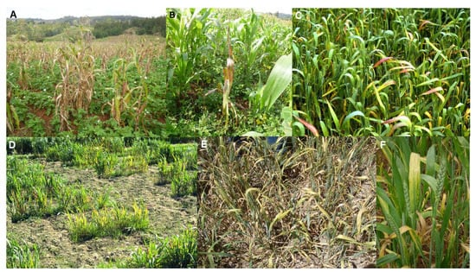 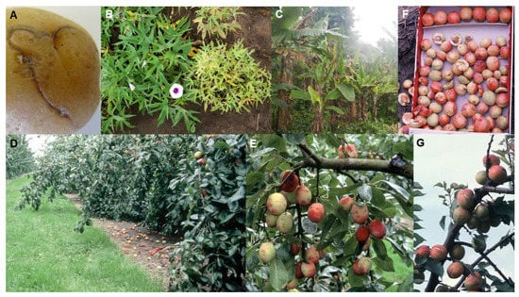

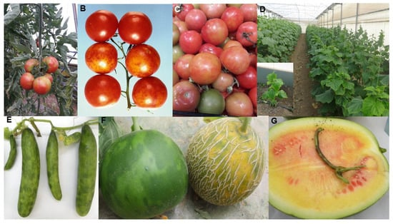 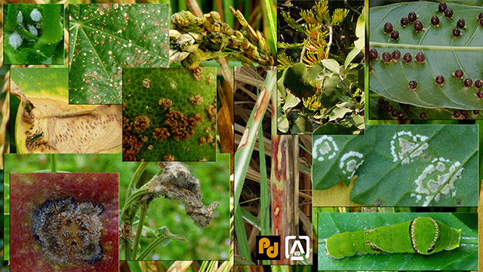

**Proposed Solution:**   
To address this issue, a Plant Disease Detection System leveraging machine learning (ML) and computer vision is proposed. The system will analyze images of plant leaves to identify signs of diseases. By integrating deep learning models with a mobile or web-based interface, farmers can capture plant images through smartphones and receive instant feedback on the health status of their crops. The system aims to provide:

* Early disease detection
* Accurate diagnosis with minimal human intervention
* Real-time recommendations for disease management
* Improved crop yield and reduced losses

**Tools and Technologies Used:**

* **Machine Learning Frameworks:** TensorFlow, PyTorch
* **Programming Languages:** Python
* **Computer Vision:** OpenCV
* **Dataset:** PlantVillage, custom datasets from local farms
* **Model:** Convolutional Neural Networks (CNNs)
* **Deployment:** Flask/Django for web-based interface, Android/iOS for mobile application
* **Cloud Integration:** Google Cloud, AWS for model training and deployment
* **User Interface:** Streamlit for developing an interactive and user-friendly web interface that allows users to upload images, visualize results, and interact with the system seamlessly.
* **Mobile Accessibility:** Streamlit's responsive design ensures the interface adapts to mobile devices, allowing farmers to access the system on the go.

**Algorithms and Techniques:**  
The core of the plant disease detection system lies in the deep learning algorithms used to classify and detect diseases from leaf images. The following techniques and models are implemented:

1. **Convolutional Neural Networks (CNNs):**  
   CNNs are employed for image classification tasks due to their ability to extract spatial features from input images. Multiple convolutional layers are used to detect patterns such as color changes, lesions, and texture variations indicative of plant diseases. Transfer learning with pre-trained models (e.g., ResNet, VGG16, and EfficientNet) is also utilized to accelerate development and enhance accuracy by leveraging models trained on large datasets. EfficientNet has shown particular promise in plant disease detection due to its efficiency and accuracy. 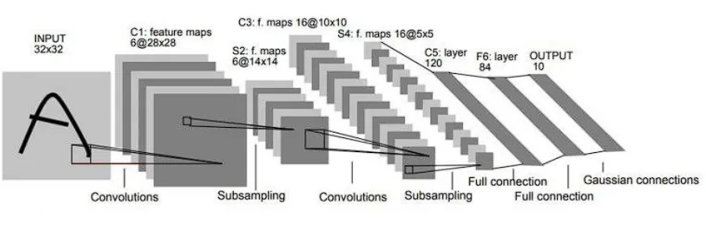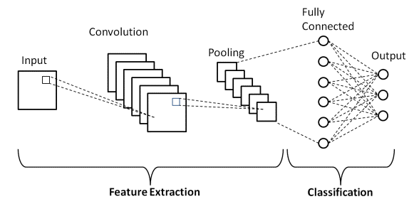
2. **Data Augmentation:**  
   Techniques like image rotation, flipping, zooming, and brightness adjustment are applied to expand the training dataset, ensuring that the model generalizes well to diverse environmental conditions and lighting. This step reduces overfitting and increases the model's robustness.

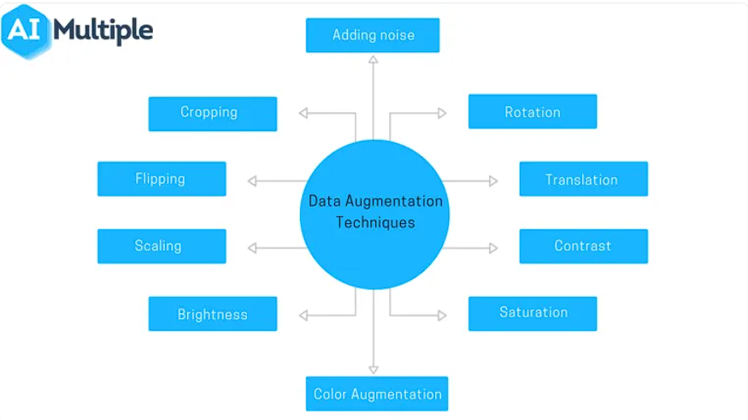

1. **Hyperparameter Tuning:**  
   Grid search and random search techniques are used to optimize model hyperparameters, such as learning rate, batch size, and the number of convolutional layers. This ensures that the model achieves the best possible performance.
2. **Class Balancing:**  
   To address class imbalance in datasets, oversampling of minority classes or synthetic data generation techniques like SMOTE (Synthetic Minority Over-sampling Technique) are applied. This prevents the model from being biased towards the majority class, ensuring fair disease detection across all plant conditions.
3. **Segmentation Algorithms:**  
   Segmentation helps isolate the diseased portions of the plant from the background, improving classification accuracy. U-Net and Mask R-CNN architectures are explored to perform pixel-wise segmentation, ensuring the system focuses on relevant regions of interest.

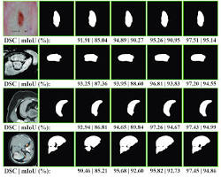

1. **Ensemble Learning:**  
   To improve accuracy further, multiple models are trained and their predictions are combined. Techniques like majority voting and weighted averaging ensure the system can handle complex cases where individual models may produce conflicting results.
2. **Explainable AI (XAI):**  
   Grad-CAM (Gradient-weighted Class Activation Mapping) is integrated to visualize the areas of the image that contribute most to the model's decision. This provides transparency and allows farmers to trust the system's recommendations.

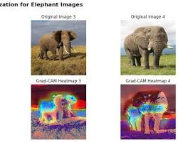

1. **Severity Assessment:**  
   In addition to disease classification, the model assesses the severity of the detected disease, quantifying the affected area. This helps farmers prioritize treatment and allocate resources effectively.
2. **Continuous Training:**  
   The model is designed to continuously learn from new images uploaded by farmers. As more data is collected, the model is retrained periodically to improve accuracy and adapt to emerging plant diseases. This ensures the system remains relevant and effective over time.

**Overview of the System:**

1. **Image Acquisition:** Farmers upload images of affected plants through the application.
2. **Preprocessing:** Images are resized, denoised, and segmented to focus on the affected areas

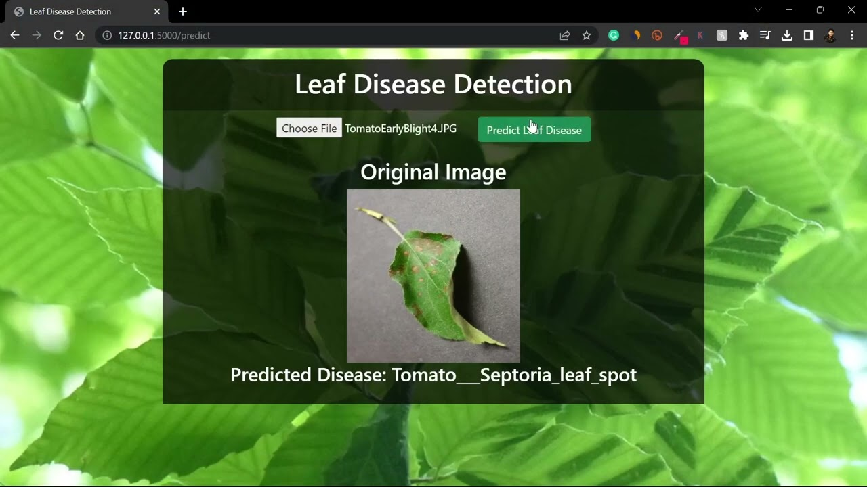.

1. **Disease Detection:** Pre-trained CNN models analyze the images and classify them into healthy or diseased categories.
2. **Severity Assessment:** The system quantifies the severity of the disease and provides detailed feedback.
3. **Output and Recommendations:** The system provides the diagnosis, probable disease, and actionable recommendations, such as pesticide suggestions or isolation of infected crops.
4. **User Interaction:** The user-friendly interface developed with Streamlit allows farmers to upload plant images, view results in real-time, and interact with visual outputs such as heatmaps highlighting diseased areas.

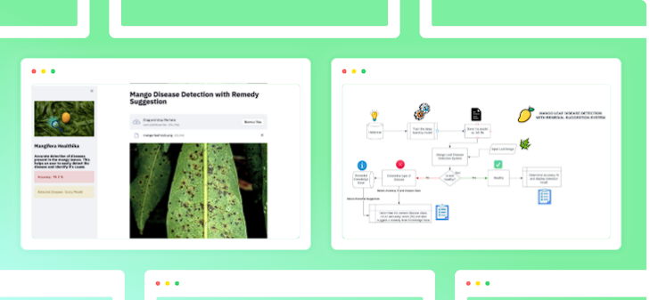

1. **Localized Recommendations:** The system integrates local agricultural databases to provide region-specific treatment recommendations.
2. **Continuous Learning:** The model is continuously updated using new data from farmers to improve accuracy and adapt to regional plant diseases.
3. **Offline Functionality:** Streamlit-based solutions are being explored to enable offline capabilities, ensuring farmers in remote areas can access the system without internet connectivity.

This system empowers farmers by providing them with an accessible, user-friendly solution to combat plant diseases, ultimately fostering sustainable agriculture practices.